Department of Commerce,

MJPTBCWRDC Women Station Ghanpur

Vision
Empowering women students, especially from backward classes in Telangana, to become successful commerce graduates equipped with knowledge, skills, and values to excel in the competitive business world and contribute meaningfully to society, with a focus on fostering women's empowerment and leadership.

Mission
- Educate: Provide high-quality commerce education to women, building a strong foundation in accounting, finance, marketing, and business management principles.
- Enlighten: Foster critical thinking, problem-solving abilities, and a global perspective for women to navigate modern commercial landscapes.
- Emancipate: Break socio-economic barriers by promoting entrepreneurship, employability, and financial literacy, with a special emphasis on empowering girls from marginalized backgrounds.
- Empower: Instill leadership, ethical values, and social responsibility, enabling students to become advocates for positive change in their communities.

Objectives
- Impart up-to-date, in-depth knowledge in commerce aligned with current curriculum and industry needs.
- Develop strong communication, analytical, and decision-making skills vital for business success.
- Offer practical learning through case studies, simulations, and internships.
- Bridge the digital divide for women by teaching essential computer and technology skills.
- Foster entrepreneurship by supporting innovative business ideas among women students.
- Promote financial literacy to help women manage personal and family finances effectively.
- Inculcate ethical practices and social responsibility within a competitive environment.
- Build self-confidence and leadership qualities specifically tailored to prepare women for future corporate and entrepreneurial roles.
- Create a supportive learning environment that celebrates cultural heritage and diversity, especially focusing on empowering girls from backward communities.
- Collaborate with government agencies, industry, and NGOs to enhance employability and provide better opportunities for women graduates.

SWOC Analysis

Strengths
- Faculty: Experienced and qualified commerce faculty dedicated to women's education.
- Curriculum: Contemporary curriculum aligned with the latest trends prepares women for immediate career opportunities.
- Industry Connections: Collaborations and partnerships enhance internship and placement prospects for women.
- Infrastructure: Women-centric learning facilities, library, and support services available on campus.
- Student Body: Motivated and focused women students create an empowering peer community.

Weaknesses
- Limited Resources: As a newly established institution (2022), infrastructure and teaching materials may require further development.
- Curriculum Updates: Keeping pace with ever-changing business skills may present challenges.
- Specialization: Fewer specialized courses might limit choices for women with niche interests.
- Faculty Development: Opportunities for upskilling women faculty could be expanded.
- Placement Support: Growing a strong placement network for women graduates may take time.

Opportunities
- Technology Integration: Digital teaching methods can boost engagement and modernize learning for women.
- Guest Lectures: Access to women achievers and professionals provides real-world insights.
- Entrepreneurship Cell: Focused support for women in starting businesses or local enterprises.
- Alumni Network: A strong community of women alumni can provide mentorship and career support.
- Government Schemes: Leverage schemes specifically aimed at women's education and infrastructural growth.

Challenges
- Competition: Growing options in women’s education may affect enrollments.
- Job Market: Economic shifts and a saturated employment landscape pose risks.
- Changing Needs: Rapid changes in commerce demand agile curriculum management.
- Student Diversity: Addressing diverse learning styles and backgrounds of women students can be complex.
- Societal Barriers: Overcoming social challenges faced uniquely by women in accessing higher education and employment.

Introduction of the Department
The Department of Commerce at MJPTBCWRDC Women, Station Ghanpur (Pembarti, Jangaon District) was established in 2022 under the aegis of Mahatma Jyothiba Phule Telangana Backward Classes Welfare Residential Educational Institutions Society (MJPTBCWREIS), Telangana State. This department is dedicated to empowering women from backward classes by offering high-quality commerce education to foster their academic growth, professional competitiveness, and meaningful societal contribution.

Vision & Mission
Vision:
To empower young women in Telangana, particularly from backward communities, to become successful commerce graduates equipped with contemporary knowledge, practical skills, and ethical values, thus enabling them to excel in the business world and serve as catalysts for community upliftment.
Mission:
- Educate: Offer comprehensive commerce education with a strong foundation in accounting, finance, marketing, and business management.
- Enlighten: Instill critical thinking, problem-solving, and a global business perspective.
- Emancipate: Break social and economic barriers by enhancing entrepreneurship, employability, and financial literacy for women.
- Empower: Nurture leadership, ethics, and social responsibility to develop agents of positive societal change.

Objectives / Goals
- Impart in-depth, up-to-date knowledge in core commerce disciplines.
- Build effective communication, analytical, and decision-making skills.
- Offer experiential learning opportunities (case studies, simulations, internships).
- Enhance digital and technological skills to bridge the digital divide.
- Promote entrepreneurship through dedicated training and support.
- Advance financial literacy and personal financial management.
- Inculcate ethical business practices and social responsibility.
- Build confidence and foster leadership among women students.
- Create an inclusive, supportive environment that celebrates diversity and women’s heritage.
- Network with government, industry, and NGOs for employability and career growth.

Courses Offered
- B.Com. (Computer Applications)
- B.Com. ( Business Analytics )

Student Strength

Year-wise Intake & Admissions
Academic Year | Programme name | Number of seats sanctioned | Number of Students admitted
2022-23 | B.Com. Computer Application | 40
2023-24 | B.Com. Computer Application | 40
2023-24 | B.Com. Business Analytics | 40
2024-25 | B.Com. Computer Application | 40
2024-25 | B.Com. Business Analytics | 40
2025-26 | B.Com. Computer Application | 40
2025-26 | B.Com. Computer Application | 40

Faculty Profile

Faculty Profile
Name: Ms. Boora Sneha
Designation: Degree Lecturer
Department: Commerce
Institution: MJPTBCWRDC (Women), Station Ghanpur

Educational Qualifications
- M.Com (Osmania University)
- NET (JRF) Qualified
- Pursuing Ph.D. (Research Scholar)

Teaching Experience
- 1 Year

Teaching Interests
- Financial Accounting
- Cost Accounting
- Cost Control and Management Accounting
- Business Economics
- Corporate Accounting
- Theory and Practice of GST
- Research Methodology

Administrative Experience
- Engaged in Ph.D. Research Work

Publications (ISBN / ISSN)
- Foreign Direct Investment in India – A Case Study of Gujarat State

Seminars / Workshops / FDPs / Orientation Programmes Participated
- [Details can be added as per participation record]

Awards & Honours
- [Details can be updated when available]

Professional Memberships
- Life Member, Telangana Commerce Association

Training & Workshops Conducted

Faculty Profile
Name: Dr. Mogilicherla.RamyaSree
Designation: Degree Lecturer
Department: Commerce
Institution: MJPTBCWRDC (Women), Station Ghanpur
Dr. Mogilicherla.RamyaSree is a highly qualified and experienced Degree Lecturer in the Department of Commerce, demonstrating a strong academic background, diverse teaching and administrative expertise, and a growing research portfolio. Her profile highlights a commitment to education, professional development, and student mentorship.

Most Important Ideas/Facts:
Academic Qualifications and Specializations:
- Dr. RamyaSree holds significant educational qualifications: "M.Com, B.Ed, SET. PhD." This combination indicates a strong foundation in commerce, pedagogical skills, and advanced research capabilities.
- Her PhD research focuses on a highly relevant and contemporary topic: "Work stress & Job Satisfaction in Selected Multinational Corporations Employees: A comprehensive Study of Work from Home Before and After Covid -19, HR Stream, Department Of Commerce, Osmania University." This demonstrates an interest in human resources and the impact of modern work environments.
Extensive Teaching Experience:
- She has a progressive teaching career, starting as a TGT Social Studies, then PGT Social Studies, and eventually transitioning to a Degree Lecturer in Commerce.
- Her current role as a "Degree Lecturer in Commerce" began on "14th August 2019" and continues to the present, indicating a sustained commitment to higher education in commerce.
- She has experience being "Selected through TSPSC" and "Selected through TREIB" for various teaching positions, highlighting her qualifications through competitive selection processes.
Diverse Teaching Interests in Commerce:
- Dr. RamyaSree possesses a broad range of teaching interests within the commerce discipline, including core subjects such as "Business organisation and Management," "Business law," "Business statistics," "Business Economics," and "Financial Accounting."
- Her interests also extend to modern applications like "Computerised Accounting" and academic skills like "Research Methodology," showcasing a comprehensive and up-to-date curriculum knowledge.
Significant Administrative Contributions:
- Beyond teaching, Dr. RamyaSree has held several key administrative roles, demonstrating leadership and organizational skills. These include:
- "Worked As Career Guidance Cell In Charge"
- "Worked as a Student Councillor (House master)"
- "Worked as Head of the Department of commerce"
- "Worked as In-charge of Commerce club"
- "Worked as Head of Criteria 2 (NAAC Accreditation)"
- "Worked as Palamuru University Assistant Examiner (Exam Paper Evaluation)"
- Her experience as "Head of Criteria 2 (NAAC Accreditation)" is particularly noteworthy, indicating involvement in quality assurance and institutional development.
Active Research and Publication Record:
- She has two recent publications in 2024:
- "A Study of Work Stress Experienced by its Employees Working in Multinational Corporations in Telangana, India" in the International Journal for Social Studies (April 2024).
- "Exploring the Job Satisfaction Trends among the MNCs IT Professionals a Study in Hyderabad, Telangana" in the International Journal of Research (IJR) (July 2024).
- These publications directly relate to her PhD research area, indicating productive scholarly output.
Commitment to Professional Development:
- Dr. RamyaSree has actively participated in numerous Faculty Development Programmes (FDPs) and workshops, many of which are from prestigious institutions like "Ramanujan College, Delhi University" and sponsored by the "Ministry of Human Resource Development."
- Her participation in FDPs like "Quantitative Methods for Data Analysis," "MANAGING ONLINE CLASSES AND CO-CREATING MOOCS 3.0," "Research Writings from Manuscript to Citations," and "Crafting Scholarly papers –FDP for Researcher’s" highlights a continuous effort to enhance her teaching and research skills, especially in contemporary methodologies and online learning.
Awards and Recognition:
- She has received commendations, including "Awarded Best online Lecturer award during Covid-19 period," which attests to her adaptability and effectiveness during challenging times.
- She was also "Awarded Regional level Best Village Learning Centre Mentor award," suggesting broader engagement and community impact.
Mentorship and Research Guidance:
- Dr. RamyaSree has taken on the role of a research supervisor, having "Guided as a Supervisor of 3 Students Study Projects in AY 2021-22," "5 Students Study Projects in AY 2022-23," "5 Students Study Projects in AY 2023-24," and "5 Students Study Projects in AY 2024-25." This demonstrates her commitment to fostering student research and academic growth.
Professional Affiliations and Initiatives:
- She is a "Life Time Member of Telengana Commerce Association," indicating involvement in professional communities.
- She has also "Organised Online National Webinar on 20/01/2020 Title “How to Identify a Research Topic”," showcasing initiative in academic knowledge dissemination.

Teaching Staff
SLNO | Name of the faculty | Designation | Nature of Appointment | Qualifications | Teaching Experience | Remarks
1 | Boora Sneha | Degree Lecturer | Regular | M.Com, NET(JRF), (Ph.D.) | 1 Year
2 | Dr. M . Ramya Sree | Degree Lecturer | Regular | M.Com, B.Ed., SET, Ph.D. | 8 Years

Category-wise Details
- All students are women, mainly from Telangana Backward Classes, as per MJPTBCWREIS norms.

Infrastructure Facilities.

Classrooms & Laboratories
- Well-equipped classrooms with modern teaching aids.
- Computer labs for commerce and IT-related subjects.

Library & Learning Resources
- Library stocked with textbooks, reference materials, and commerce journals.
- Online learning resources and access to digital libraries.

ICT Facilities
- Computers with internet connectivity for students and faculty.
- Smart boards/projectors as part of ICT-enabled teaching.
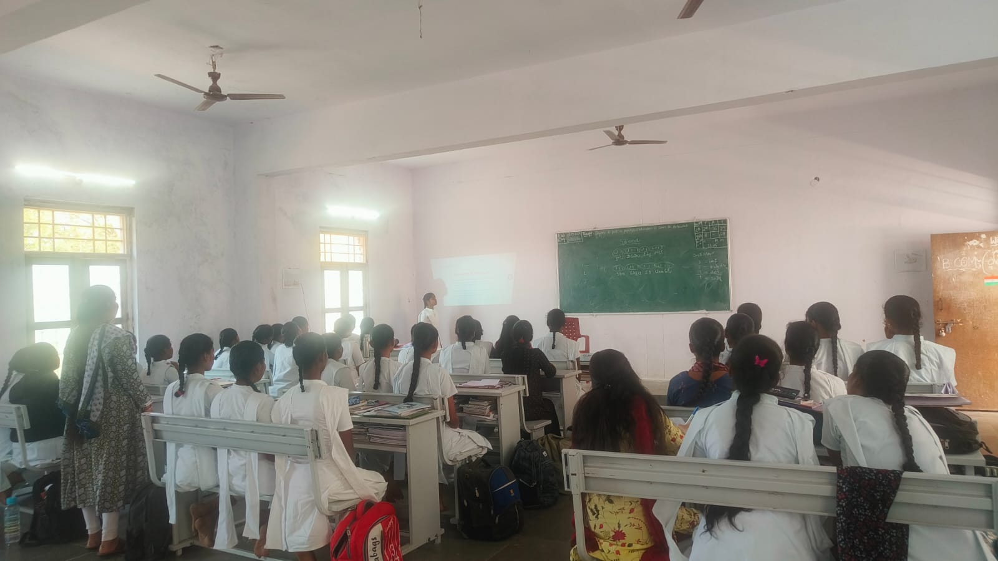

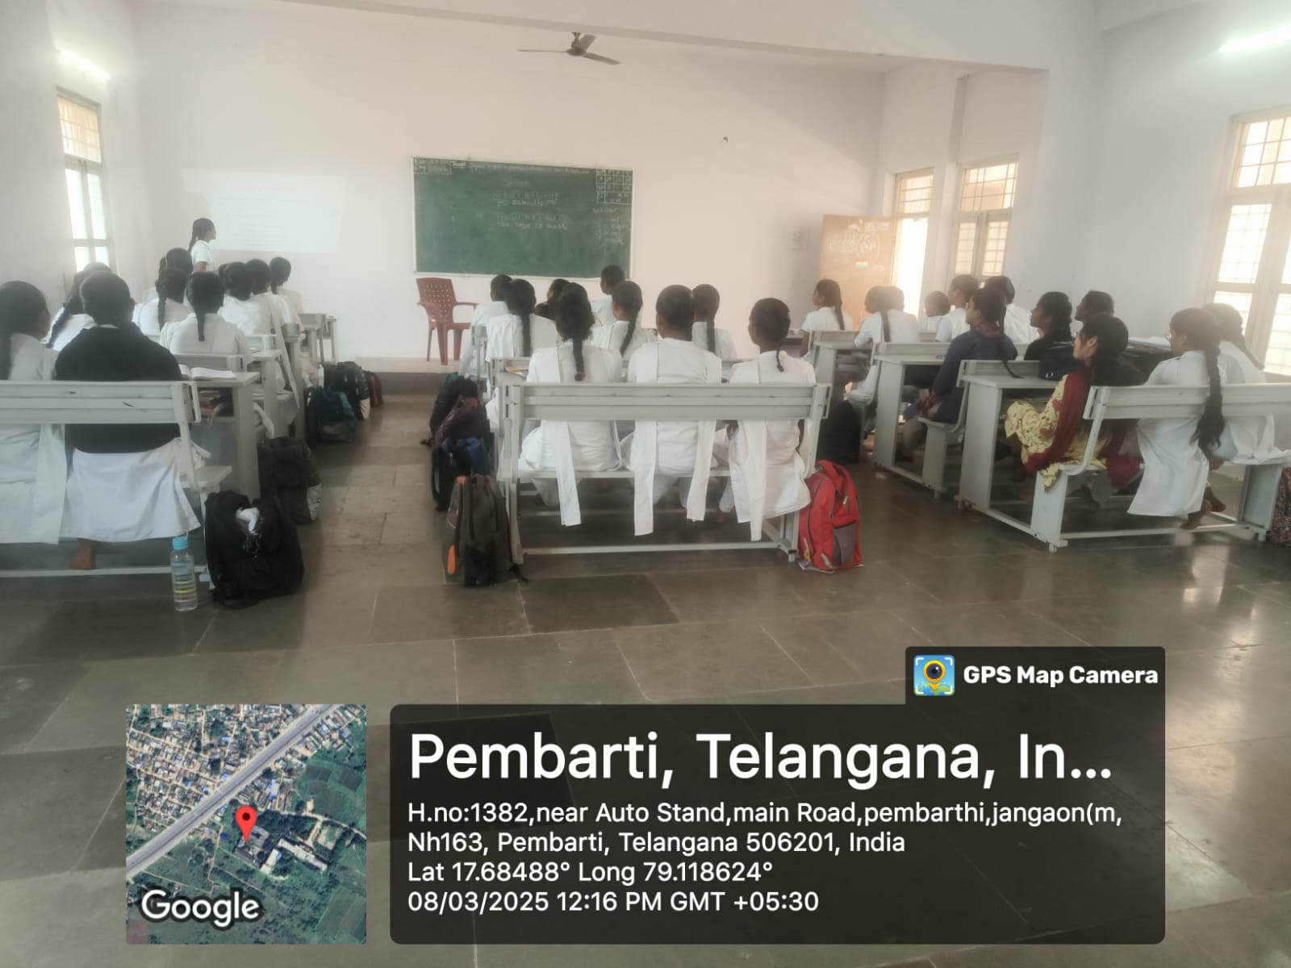

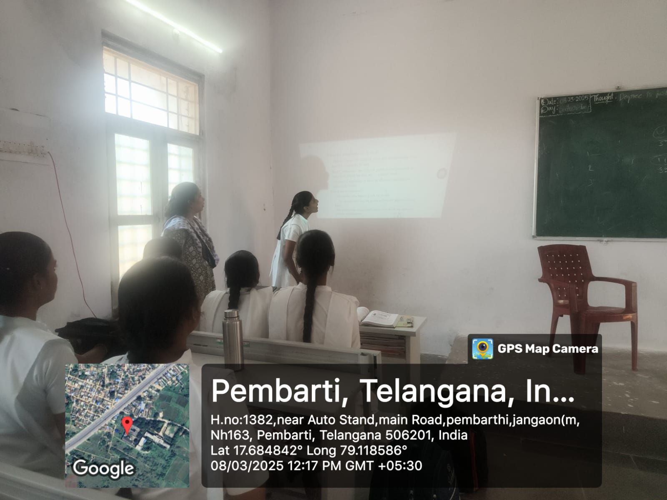

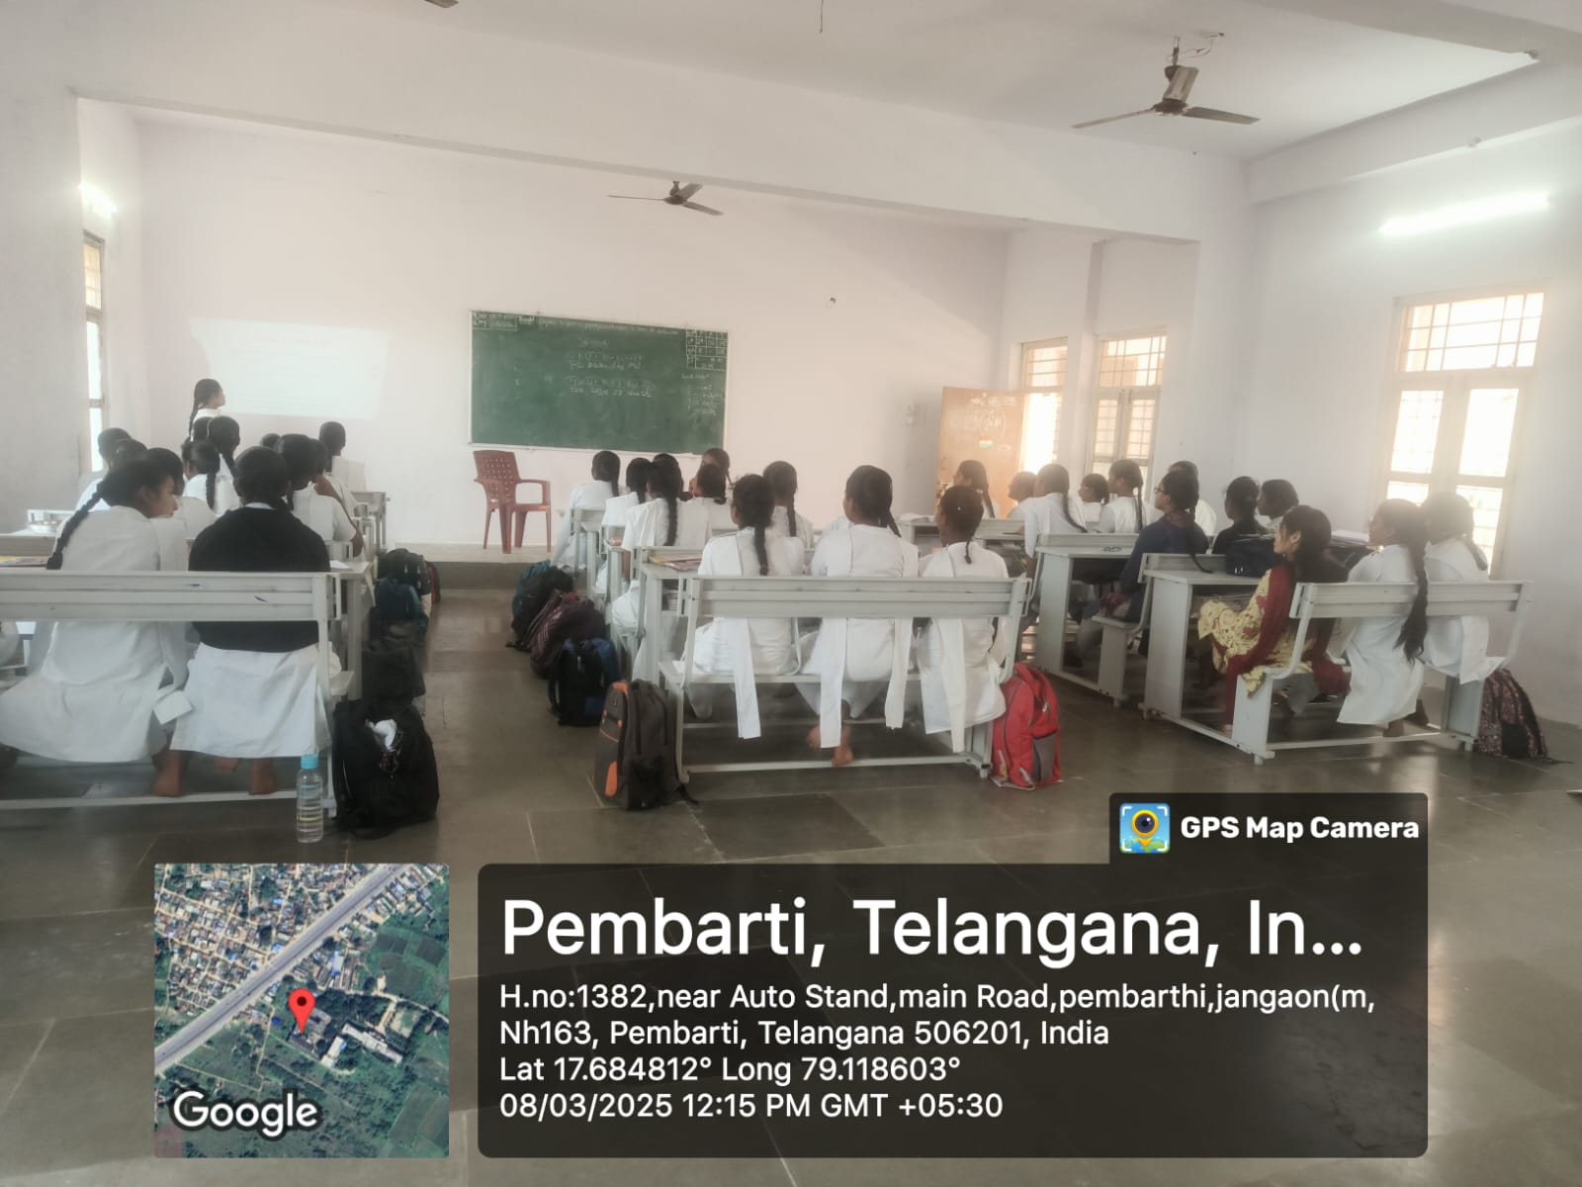

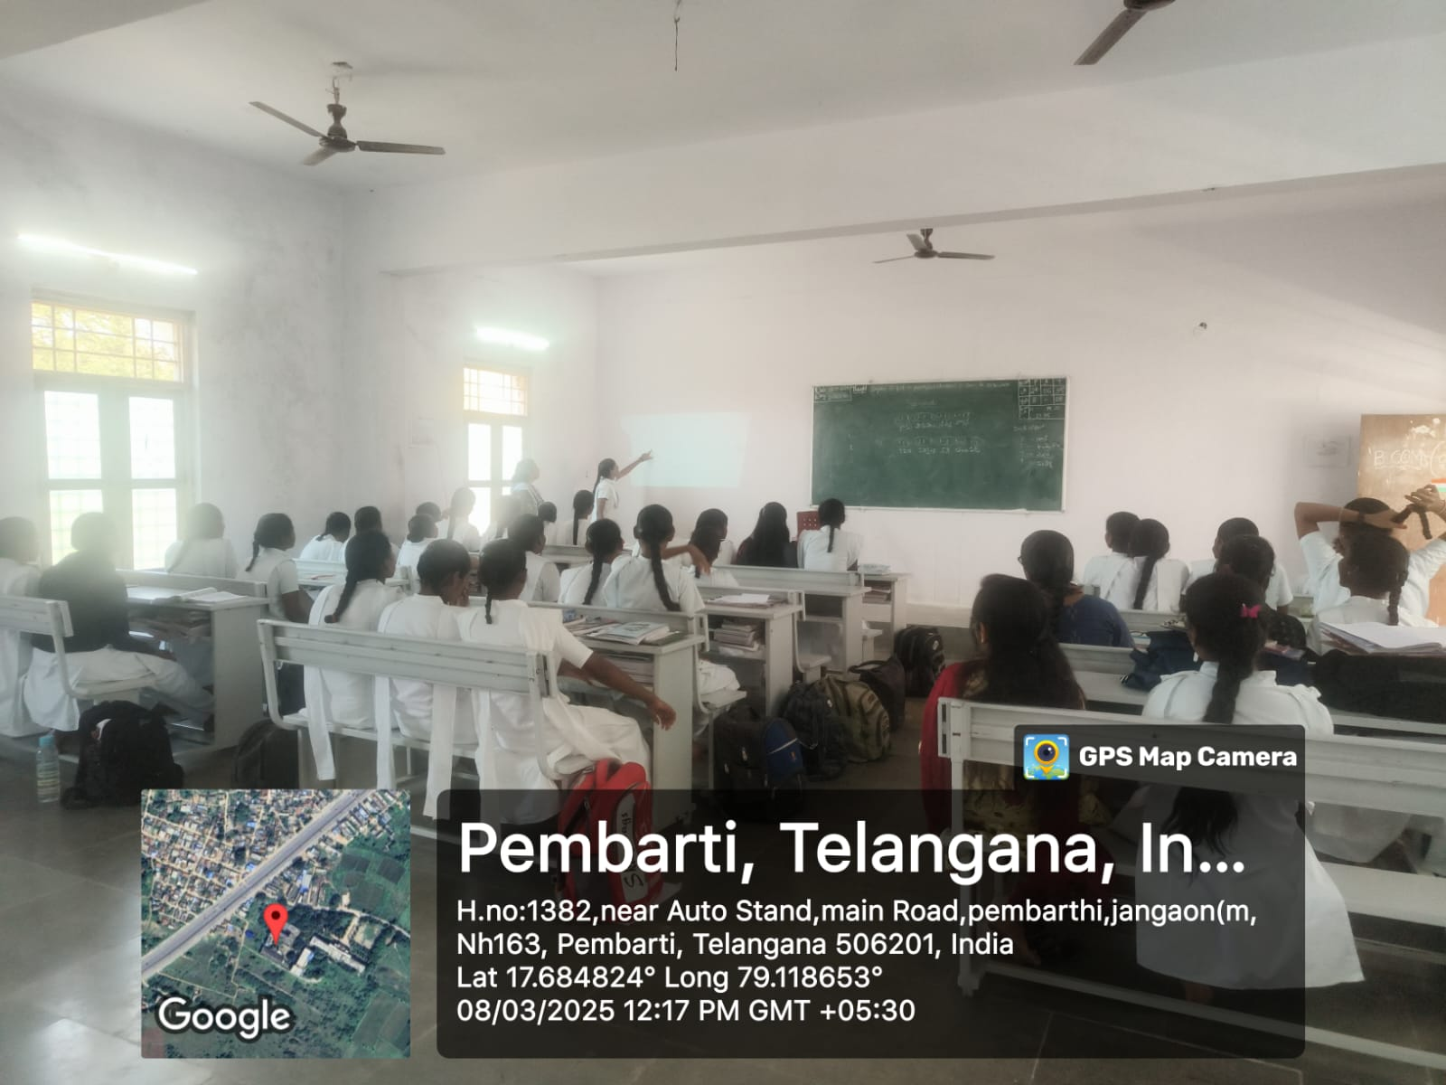

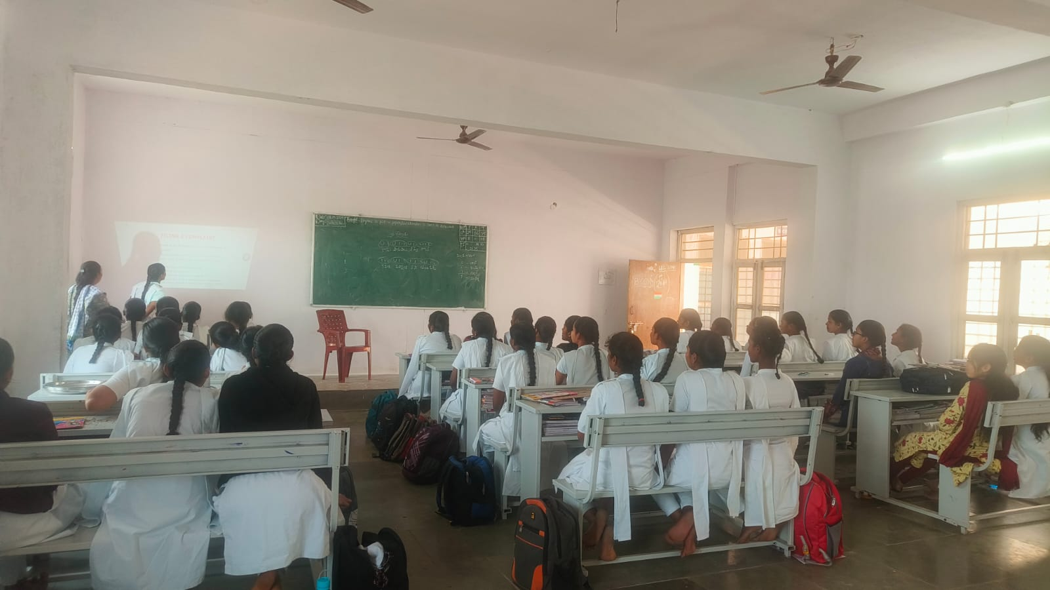

SWOC Analysis
Strengths
- Faculty: Qualified staff fostering a strong commerce foundation.
- Women-centric: Focused support and a safe learning environment for women.
- Infrastructure: Modern classes, computer labs, and library.
- Curriculum Alignment: Focus on current business trends to enhance employability.
- Backing of MJPTBCWREIS: Backed by a robust state educational society providing scholarships and support.
Weaknesses
- Resource Constraints: New institution with evolving resources and facilities.
- Industry Exposure: Building stronger industry ties and placement support is ongoing.
- Faculty Development: Opportunities for advanced upskilling may be limited.
Opportunities
- Technology Integration: Scope for digital learning enhancements.
- Women Empowerment Initiatives: Schemes and partnerships for women’s skills development.
- Entrepreneurship Cell: Potential to foster business startups led by women.
Challenges
- Competition: Competing with established colleges for student intake.
- Placement Ecosystem: Need for stronger pathways to quality employment.
- Changing Curriculum Needs: Keeping pace with rapid industry transformation.

Research & Publications

Faculty Research Work.
Dr.M. Ramyasree.
Publications: (ISBN Publications)
- “A Study of Work Stress Experienced by its Employees Working in Multinational Corporations in Telangana, India” International Journal for Social Studies ISSN: 2455-3220 Volume 10 Issue 04 April 2024
- “Exploring the Job Satisfaction Trends among the MNCs IT Professionals a Study in Hyderabad, Telangana” International Journal of Research (IJR) e-ISSN: 2348-6848 p-ISSN: 2348-795X Vol. 11 Issue 07 July 2024.
Seminars/ Workshops/ FDP’s/ Orientation Programmes Participated:
- Attended a Two Weeks Faculty Development Programme on “Quantitative Methods for Data Analysis” in Ministry of Human Resource Development, Pandit Madan Mohan Malaviya National Mission on Teaching and Learning Centre, Ramanujan College, Delhi University on August 12 - August 25, 2020.

- Attended a Two Week Faculty Development Programme on "MANAGING ONLINE CLASSES AND CO-CREATING MOOCS 3.0" in Ministry of Human Resource Development, Pandit Madan Mohan Malaviya National Mission on Teaching and Learning Centre, Ramanujan College, Delhi University on July 25 - August 10, 2020.

- Attended a Five Day Faculty Development Programme on “Research Writings from Manuscript to Citations” by CBM- School of Business Excellence. hyd

- Attended a One day Work Shop on “ Research Methodology & Project report preparation” Organised By Telangana Commerce association & Palamuru University on 20th April 2022

- Attended a Five Day Faculty Development Programme on “Crafting Scholarly papers –FDP for Researcher’s” by Institute of Public Enterprises on 20 Nov 2023 to 24 Nov 2023.

Student Research / Projects
BCOM (Computer Application) SEMESTER VI Research methodology projects AY 2024-25
Group | Title of the project | Number of students | Hall ticket number | Names of the Students | Method of data Collection | Supervisor
Bcom CA | The impact of digital payment on consumer behaviour and spending patterns | 4 | 660232007 | Jurru Thrisha rani | Data Collection Directly | DR M.RAMYASREE
Bcom CA |  | 4 | 660232011 | Nethula Ravali | Data Collection Directly | DR M.RAMYASREE
Bcom CA |  | 4 | 660232010 | kommula Anjali | Data Collection Directly | DR M.RAMYASREE
Bcom CA |  | 4 | 660232016 | Ulli meghana | Data Collection Directly | DR M.RAMYASREE
Bcom CA | Exploring opportunities and challenges of metal handicrafts and brass workers in village | 4 | 660232001 | Akkem Thirumala | Data Collection Directly | DR M.RAMYASREE
Bcom CA |  | 4 | 660232002 | Jangam Nandini | Data Collection Directly | DR M.RAMYASREE
Bcom CA |  | 4 | 660232018 | vutnoor vaishnavi | Data Collection Directly | DR M.RAMYASREE
Bcom CA |  | 4 | 660232015 | Sanjya Rashmitha | Data Collection Directly | DR M.RAMYASREE
Bcom CA | A study on impact of Mahalaxmi scheme with special reference to pemberthi | 5 | 660232013 | perumandla Ramya | Data Collection Directly | DR M.RAMYASREE
Bcom CA |  | 5 | 660232004 | Ettamalla Sravani | Data Collection Directly | B.sneha
Bcom CA |  | 5 | 660232005 | Gandla Anjali | Data Collection Directly | B.sneha
Bcom CA |  | 5 | 660232012 | patturi prasanna | Data Collection Directly | B.sneha
Bcom CA |  | 5 | 660232017 | veeramalla sravanthi | Data Collection Directly | B.sneha
Bcom CA | The impact of social media on women empowerment and represention | 4 | 660232008 | kanneboina manasa | Data Collection Directly | DR M.RAMYASREE
Bcom CA |  | 4 | 660232009 | kasarla sowmya | Data Collection Directly | DR M.RAMYASREE
Bcom CA |  | 4 | 660232002 | Algam sravani | Data Collection Directly | DR M.RAMYASREE
Bcom CA |  | 4 | 660232014 | ponnam lavanya | Data Collection Directly | DR M.RAMYASREE

9. Academic Achievements
Results / Pass Percentage
Academic year 2022-23
SLNO | Group | Semester |  | Appeared |  | Passed |  | Failed |  | Pass %
1 | BCOM (Computer Applications) | I | 18 |  | 17 |  | 1 |  | 94%
Total |  |  | 17 |  | 17 |  | 0 |  | 100%

Academic year 2022-23
SLNO | Group | Semester |  | Appeared |  | Passed |  | Failed |  | Pass %
1 | BCOM (Computer Applications) | II | 17 |  | 15 |  | 2 |  | 88%
Total |  |  | 17 |  | 17 |  | 0 |  | 100%

Academic year 2023-24
SLNO | Group | Semester |  | Appeared |  | Passed |  | Failed |  | Pass %
1 | BCOM (Computer Applications) | III | 17 |  | 15 |  | 2 |  | 88%
2 | BCOM (Computer Applications) | I | 34 |  | 31 |  | 3 |  | 91%
3 | BCOM (Business Analytics) | I | 10 |  | 8 |  | 2 |  | 80%
Total

Academic year 2023-24
SLNO | Group | Semester |  | Appeared |  | Passed |  | Failed |  | Pass %
1 | BCOM (Computer Applications) | IV | 17 |  | 16 |  | 1 |  | 94%
2 | BCOM (Computer Applications) | II | 35 |  | 30 |  | 5 |  | 85.7
3 | BCOM (Business Analytics) | II | 10 |  | 10 |  |  |  | 100
Total

Academic year 2024-25
SLNO | Group | Semester |  | Appeared |  | Passed |  | Failed |  | Pass %
1 | BCOM (Computer Applications) | V | 17 |  | 17 |  | 0 |  | 100%
2 | BCOM (Computer Applications) | III | 32 |  | 28 |  | 4 |  | 87.5
3 | BCOM (Business Analytics) | III | 8 |  | 7 |  | 1 |  | 87.5
4 | BCOM (Computer Applications) | I | 35 |  | 30 |  | 5 |  | 85.71
5 | BCOM (Business Analytics) | I | 8 |  | 7 |  | 1 |  | 87.50
Total

Academic year 2024-25
SLNO | Group | Semester |  | Appeared |  | Passed |  | Failed |  | Pass %
1 | BCOM (Computer Applications) | VI | 17 |  | 16 |  | 0 |  | 94%
2 | BCOM (Computer Applications) | IV | 30 |  | 29 |  | 1 |  | 96.66
3 | BCOM (Business Analytics) | IV | 8 |  | 6 |  | 2 |  | 75
4 | BCOM (Computer Applications) | II | 34 |  | 28 |  | 6 |  | 82.35
5 | BCOM (Business Analytics) | II | 8 |  | 6 |  | 2 |  | 75%
Total

10. Student Activities
Students Seminars,
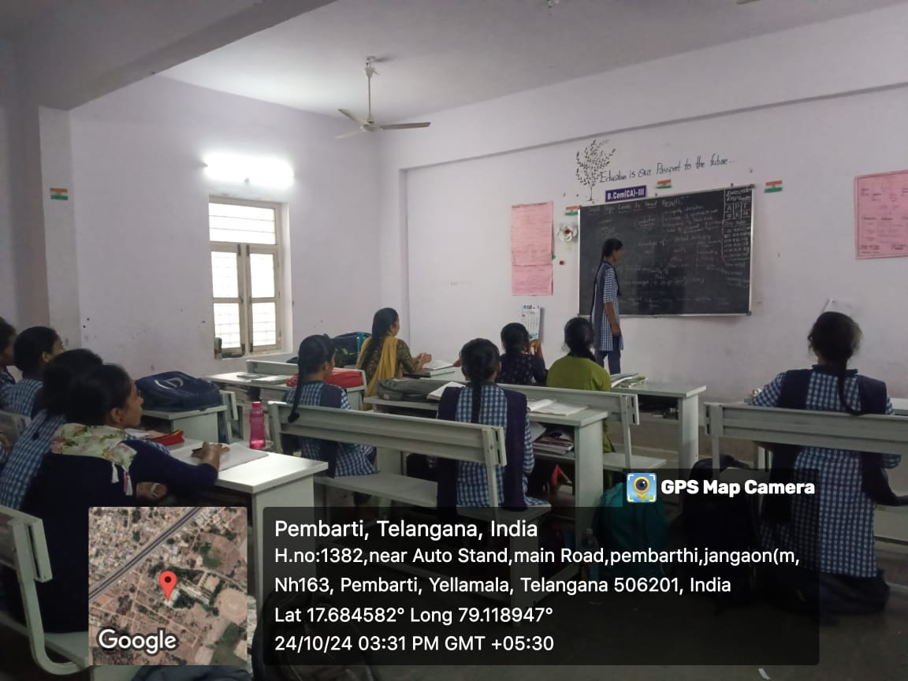
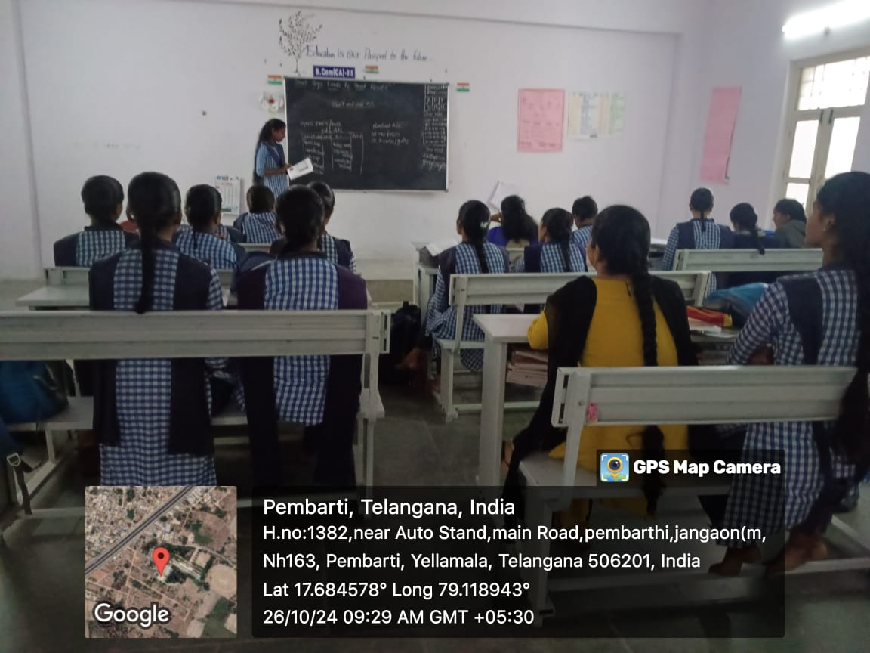
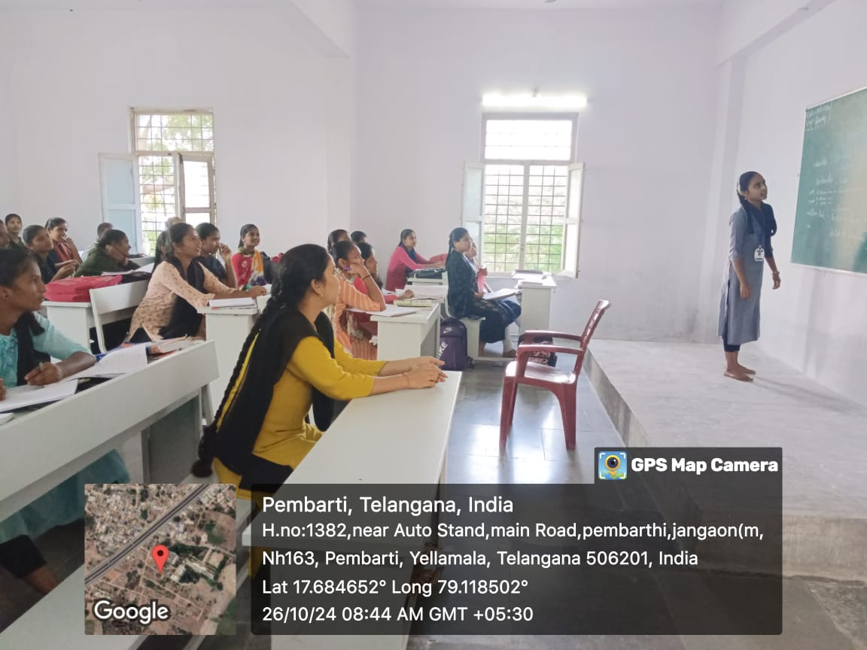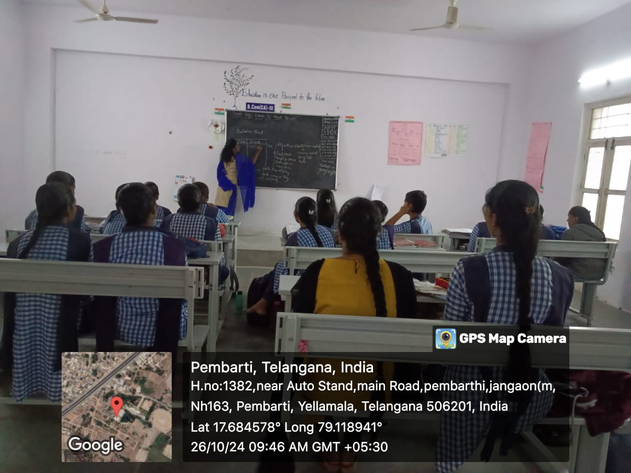
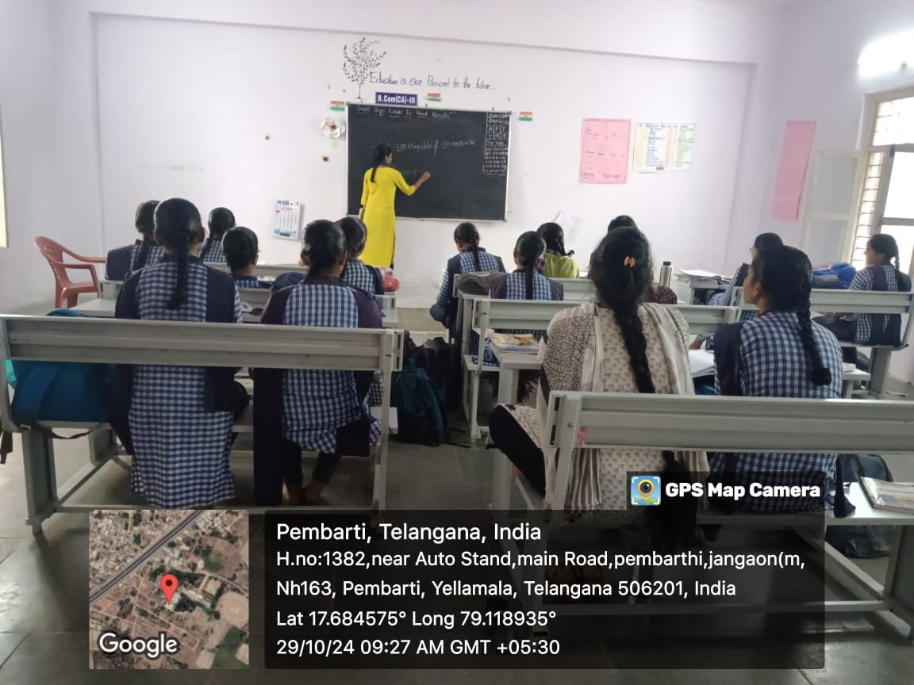
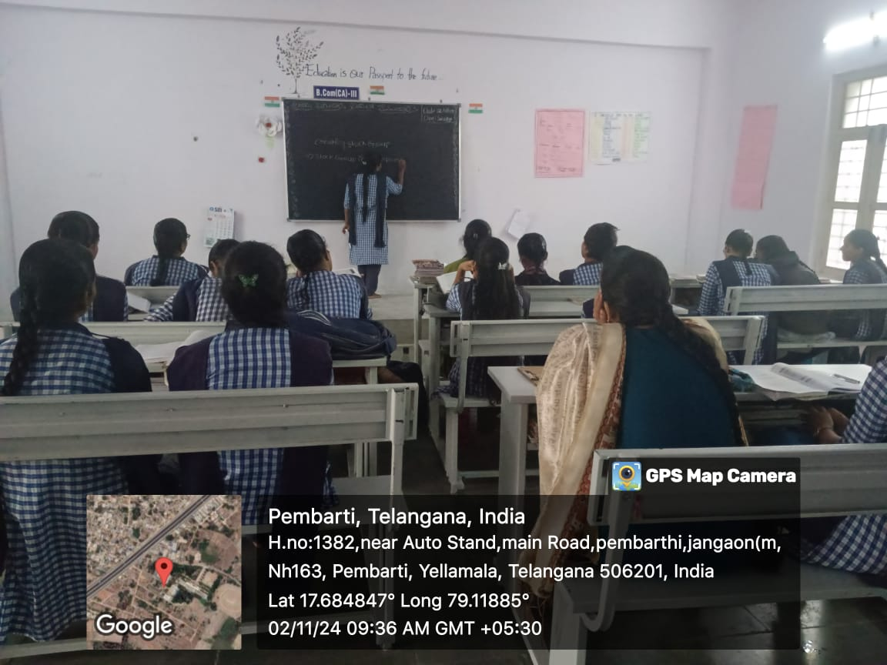

Workshops,
Guest Lectures
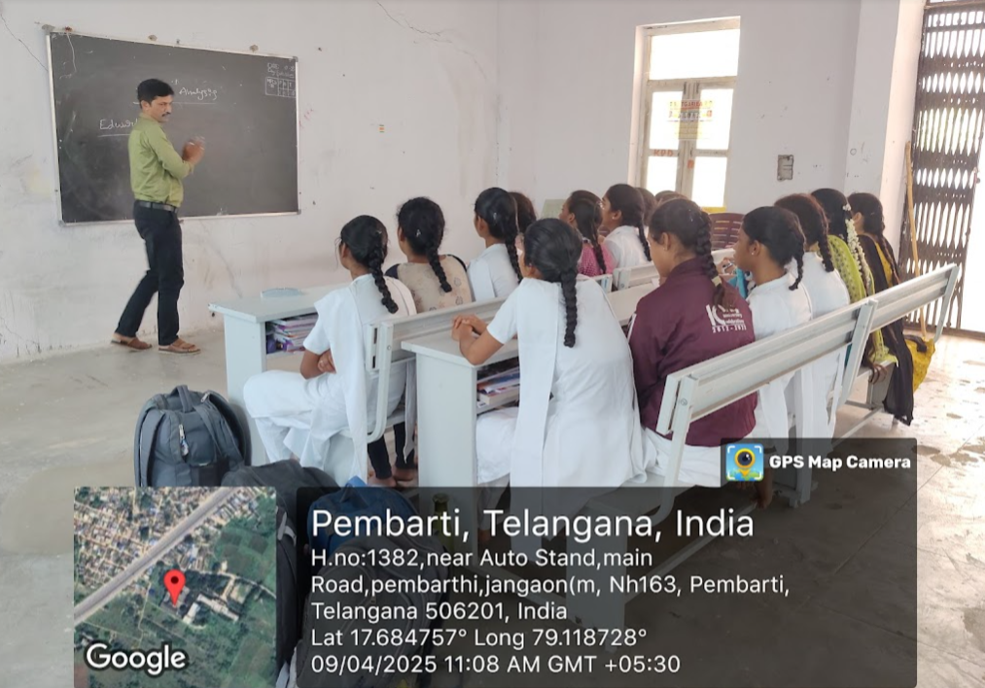
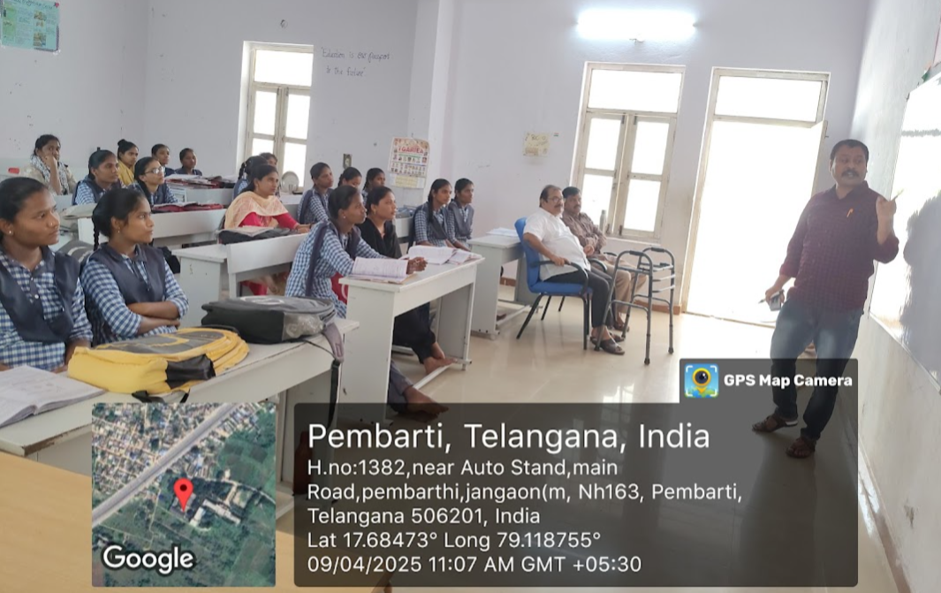
Clubs, Associations,
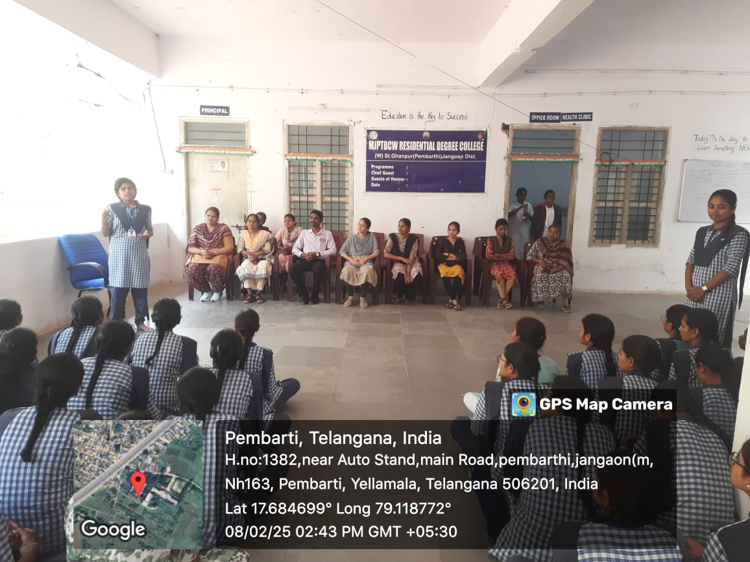
Cultural & Sports Activities
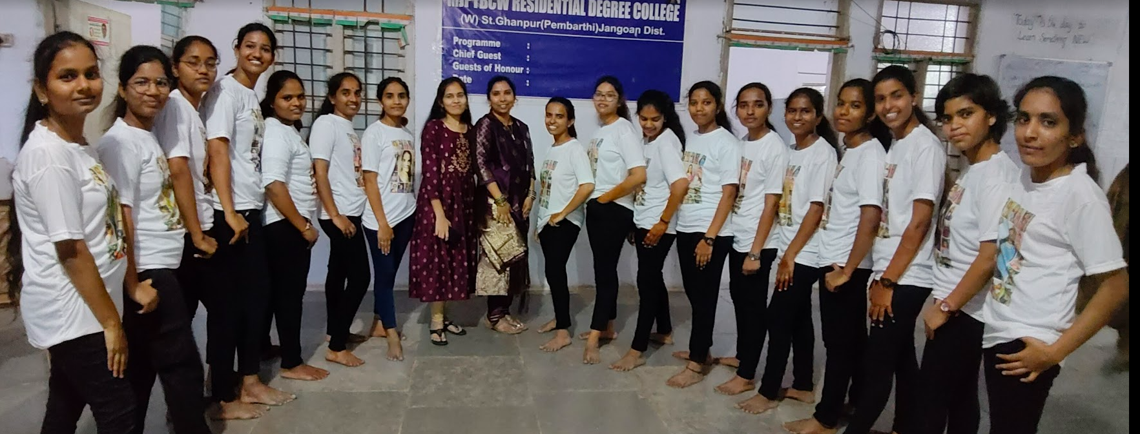

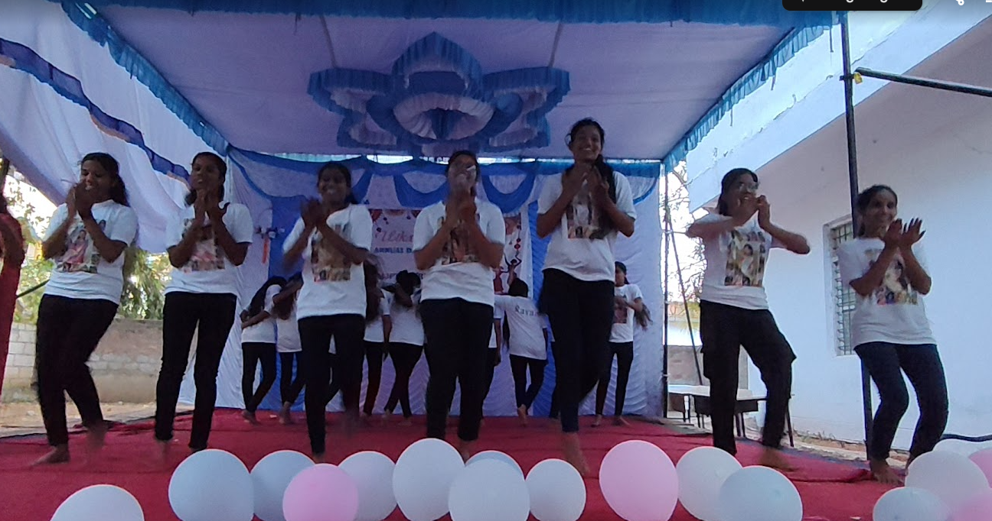

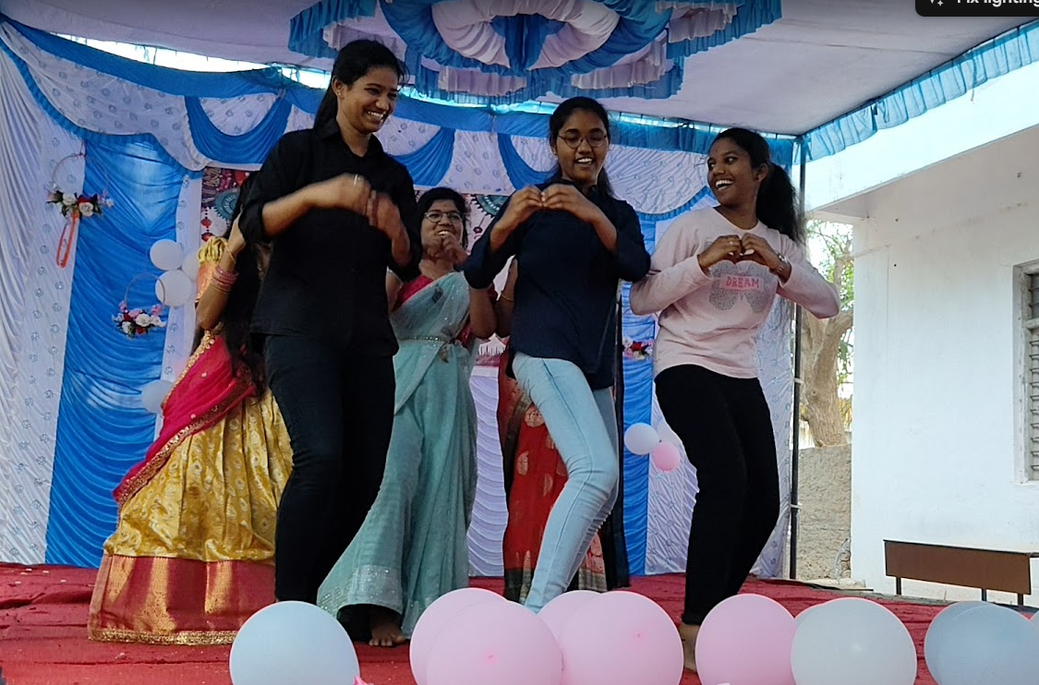

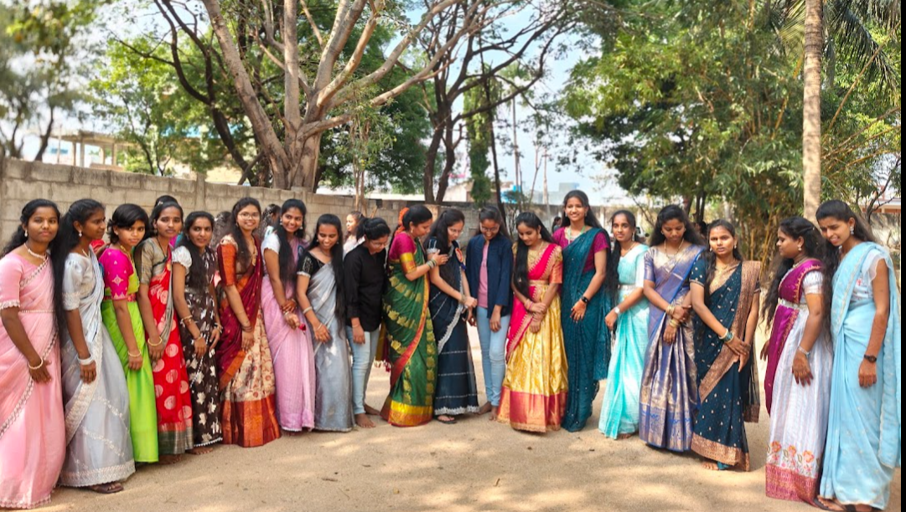

11. Extension Activities / Community Outreach
As part of the Research Project and Community Engagement, the Department of Commerce organized a field visit to Pembati Village, which is renowned for its traditional metal crafts and designs.
- The visit provided students with an opportunity to understand the economic, cultural, and artistic significance of metal craftwork in rural livelihoods.
- Students interacted with local artisans to learn about their production processes, marketing challenges, and sustainability issues.
- The activity also aimed to bridge classroom learning with real-life applications, encouraging students to explore concepts of rural entrepreneurship, small-scale industries, and community-based business models.
- This outreach not only enriched student learning but also created awareness among them about the need to support and preserve indigenous crafts through entrepreneurship, branding, and modern market linkages.
Through such initiatives, the department continues to promote experiential learning, social responsibility, and community empowerment among students.
12. Placements & Higher Education

13. Alumni Details

14. Strengths of the Department

Strengths of the Department of Commerce
- Qualified Faculty – The department has well-qualified and dedicated faculty members with strong academic backgrounds (NET/JRF, Ph.D. pursuing/awarded) who are committed to excellence in teaching and research.
- Student-Centric Teaching – Use of innovative and interactive teaching methods, ICT-enabled learning, case studies, and project-based approaches to enhance conceptual clarity and application skills.
- Strong Curriculum Base – Courses designed to meet both academic and industry requirements, with special focus on Accounting, Finance, Economics, GST, and Research Methodology.
- Focus on Research & Innovation – Faculty and students actively encouraged to engage in research, publications, paper presentations, and mini-projects, cultivating analytical and critical thinking skills.
- Skill Development Initiatives – Training on communication, soft skills, entrepreneurship, and career guidance to prepare students for higher education, competitive exams, and placements.
- Consistent Academic Performance – The department has been maintaining good academic results with high pass percentages and university ranks/distinctions by students.
- Collaborations & Professional Memberships – Faculty involvement in academic associations and professional bodies that provide networking opportunities and keep the department updated with recent trends in Commerce and Management.
- Holistic Development of Students – Regular organization of seminars, workshops, commerce club activities, field visits, and extension activities for overall personality development.
- Supportive Infrastructure – Well-equipped classrooms, library resources, ICT facilities, and access to digital platforms for effective teaching-learning.
- Mentorship & Guidance – Individual attention and mentorship provided to students, encouraging them to pursue higher education, research, and career opportunities.

15. Future Plans
- Academic Enrichment
- Introduce Certificate/Value-Added Courses in Accounting Software (Tally, SAP), GST, Digital Marketing, and E-Commerce.
- Strengthen curriculum delivery through ICT tools, virtual classrooms, and blended learning methods.
- Research & Publications
- Encourage faculty and students to undertake more research projects, publish in reputed journals, and present papers at national and international conferences.
- Establish a Research Cell to promote case studies, surveys, and minor research projects.
- Skill Development & Employability
- Organize workshops on entrepreneurship, business communication, and financial literacy.
- Conduct career guidance and placement training programs in collaboration with industries and academic bodies.
- Collaborations & Linkages
- Build MoUs with industries, professional institutions, and chartered accountancy firms for internships and practical exposure.
- Strengthen alumni network for mentoring, placements, and knowledge sharing.
- Student Development
- Expand the activities of the Commerce Club to encourage innovation, debates, and competitions.
- Motivate students to pursue higher studies (MBA, CA, CS, CMA, ICWA, NET/JRF) and prepare for competitive examinations.
- Infrastructure Enhancement
- Upgrade departmental library with more reference books, journals, and e-resources.
- Establish a Commerce Lab for practical training in accounting, finance, and taxation.
- Community & Extension Activities
- Organize financial awareness programmes, workshops on entrepreneurship for rural youth, and extension services for women empowerment.

